

SARE BANNERS ME SAME IMAGES H. PLS CHANGE AND REFRAME ALL BANNER TEXTS

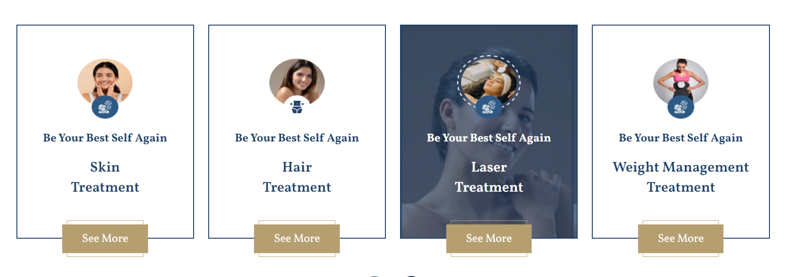

INME BG IAMGE MODEL NHI.. SERVICE RELATED LGA DO AND CIRCLE ME BHI IMAGES SERVICE BASED JAEGI NOT MODELS

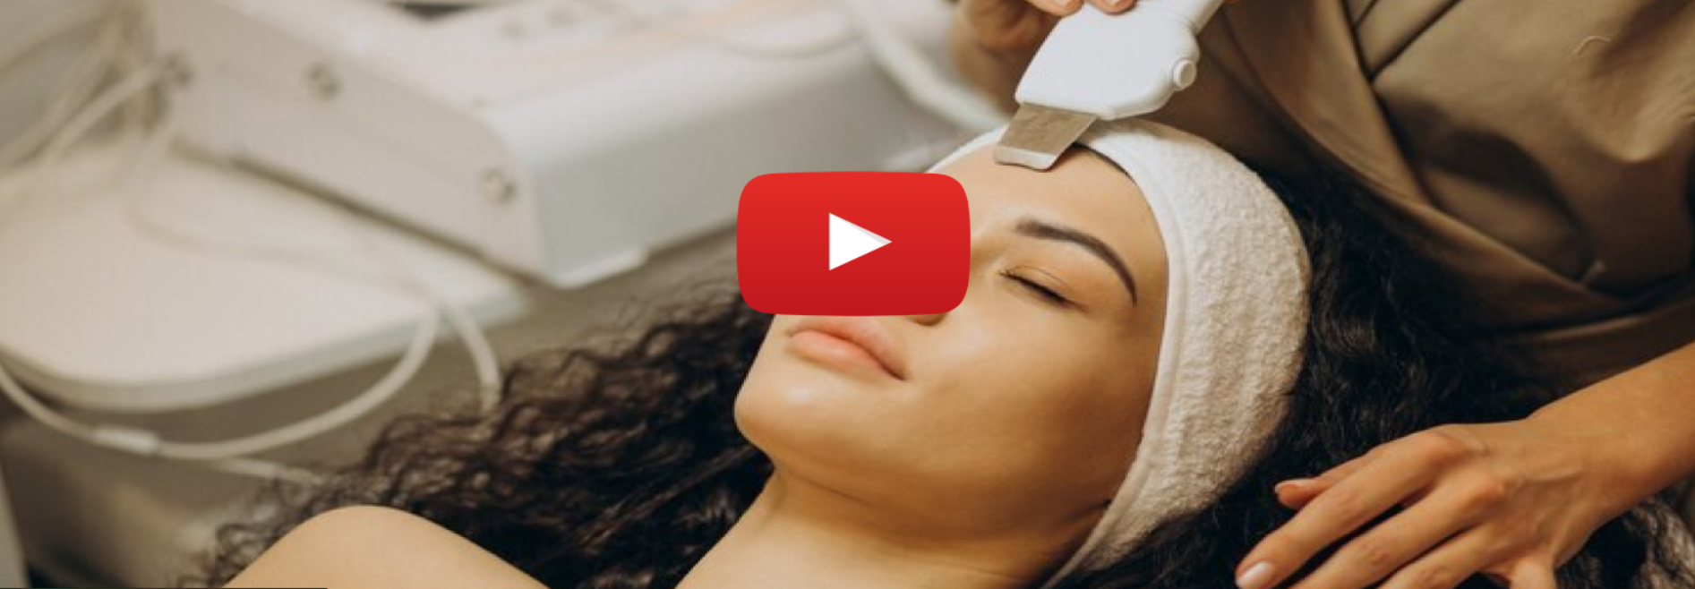

CHANGE VIDEO AS PROVIDED OR USE THIS <https://we.tl/t-PHlv6iNMmE>

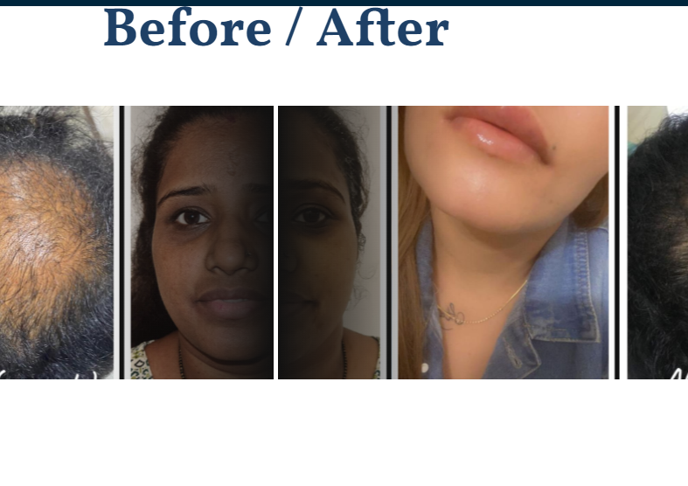

SLIDE BAR KE SIDE ME BLACK SHADOW THDA KUM KRDO

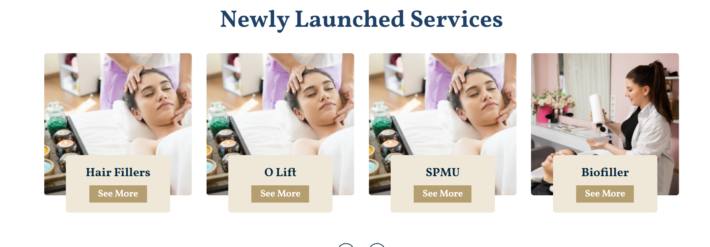

SAME IMAGES REPEAT HO RHI H. PLS CHANGE

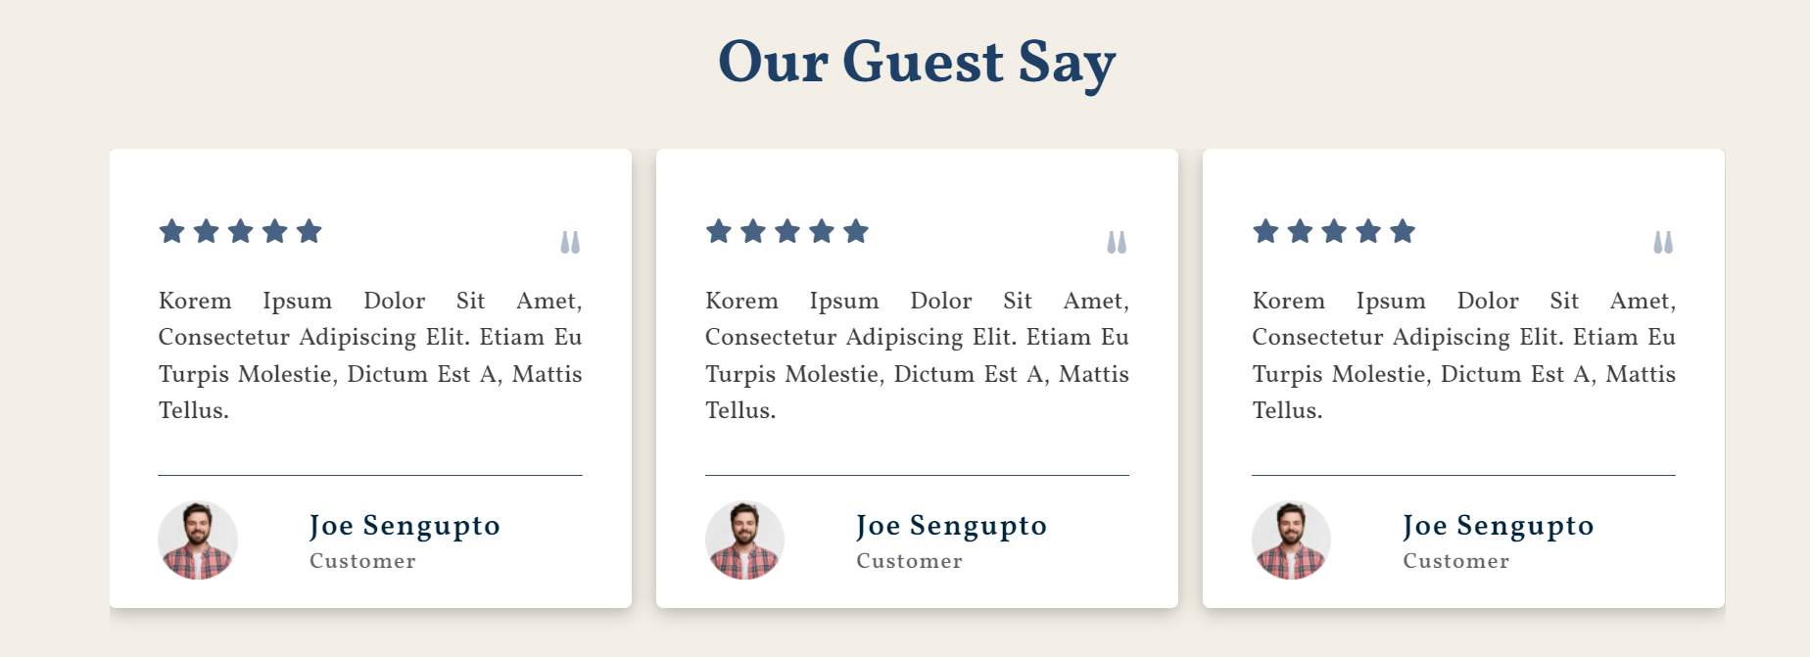

TESTIMONIAL VIDEOS USE THIS LINK - <https://we.tl/t-uzR8KCtCUJ>

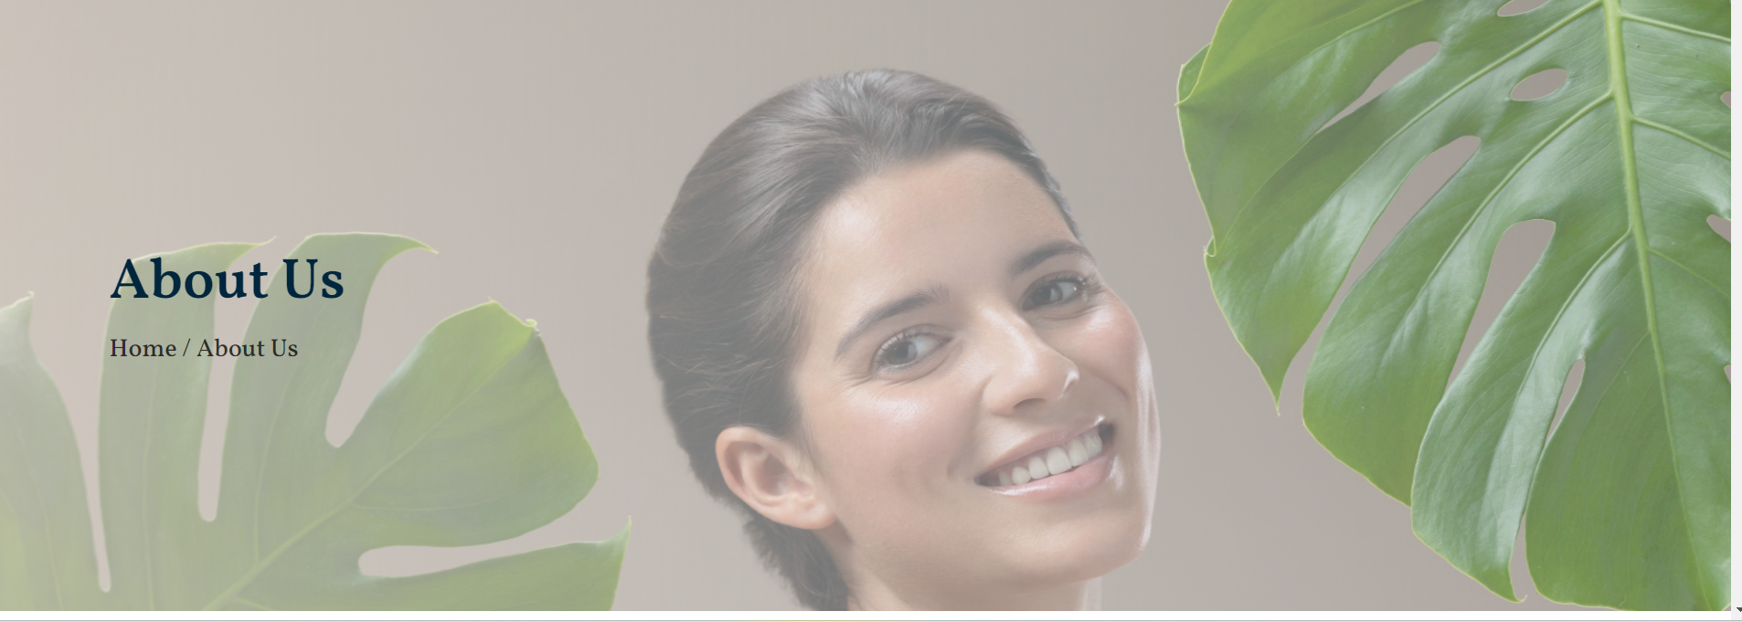

CHANGE IMAGE.. ONLY LEAFS ARE VISIBLE. Pachouli ki image lga do

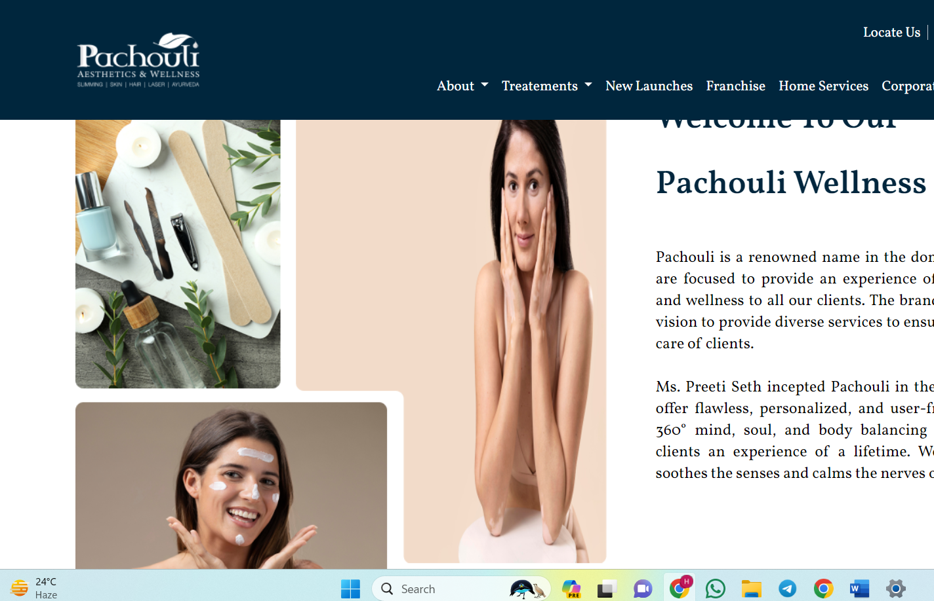

Change images. Pachouli center ki image lga do

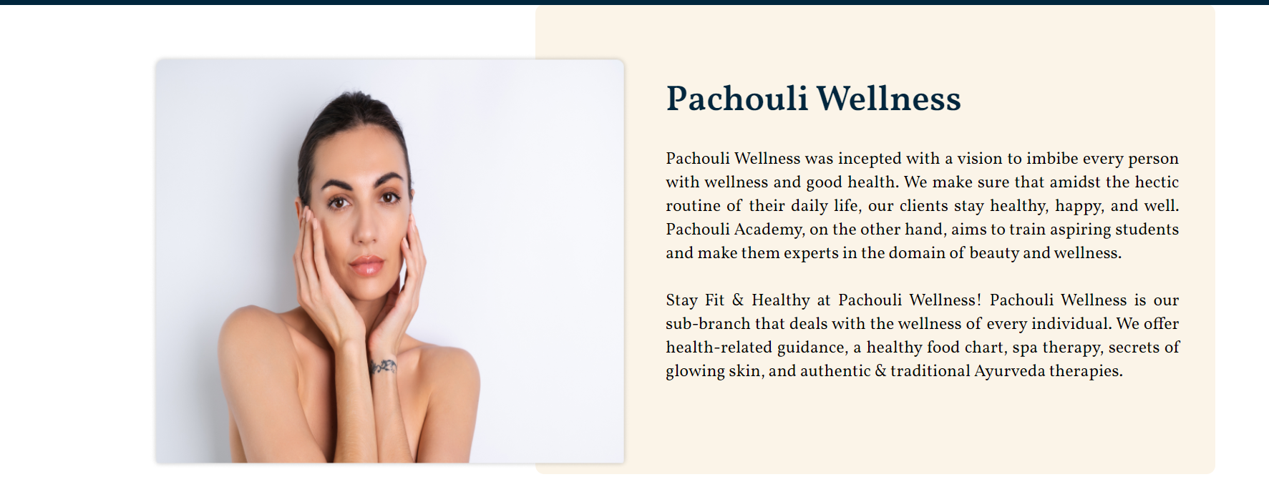



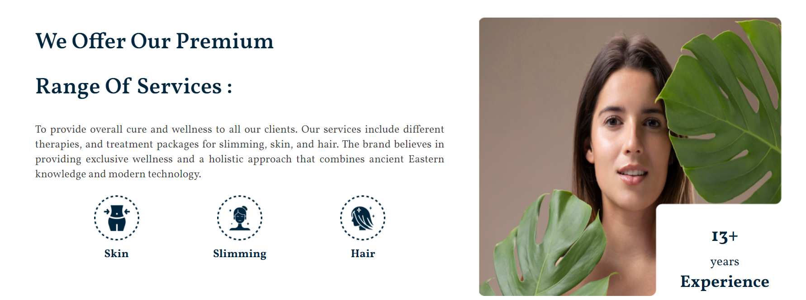

Show all 5 services in icon … change image.. relevant to pachouli (koi service or store ki lga do)



Change background image- no hair cutting image

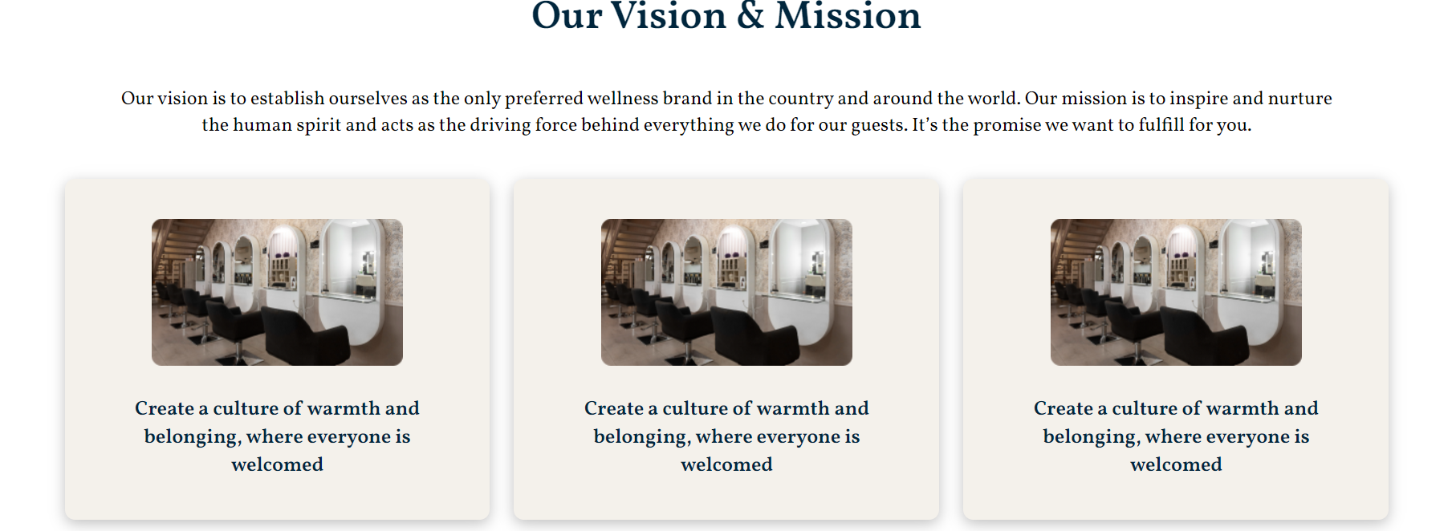

Repeated text and change image

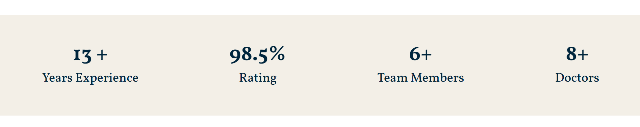

Change the meter as discussed

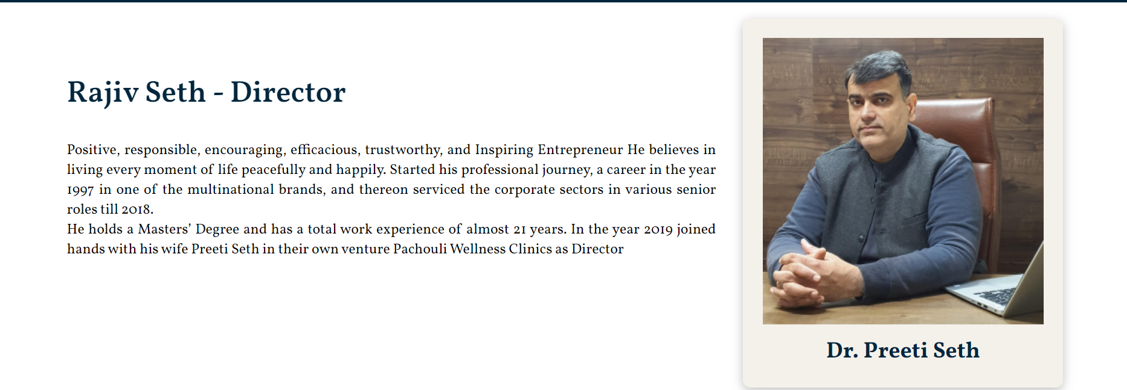

Change name below the image

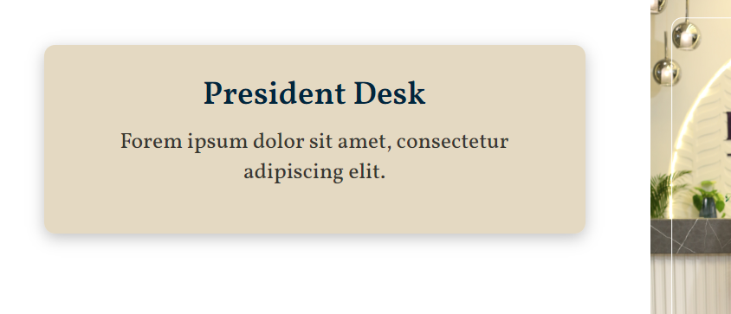

In sab titles me se lorem ipsum hta do

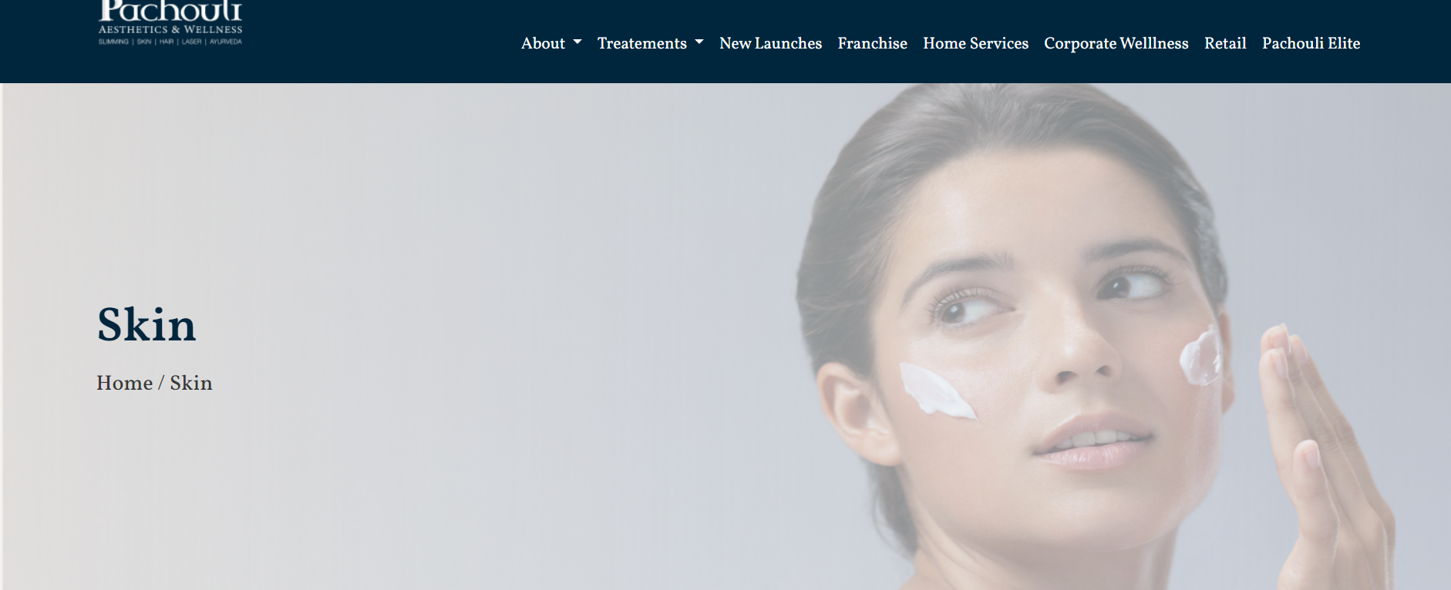

Change banner- use relevant iamges

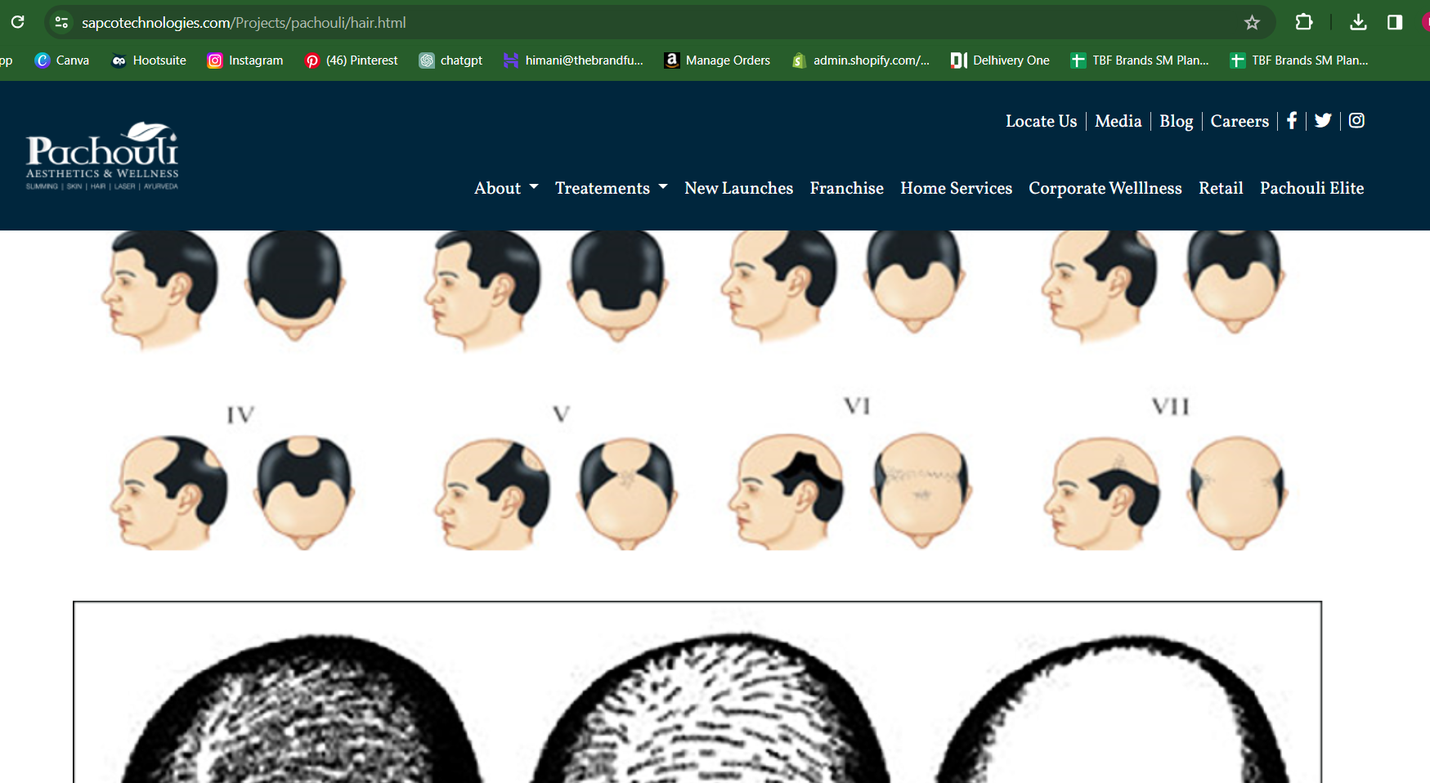  
iamge size toooo big

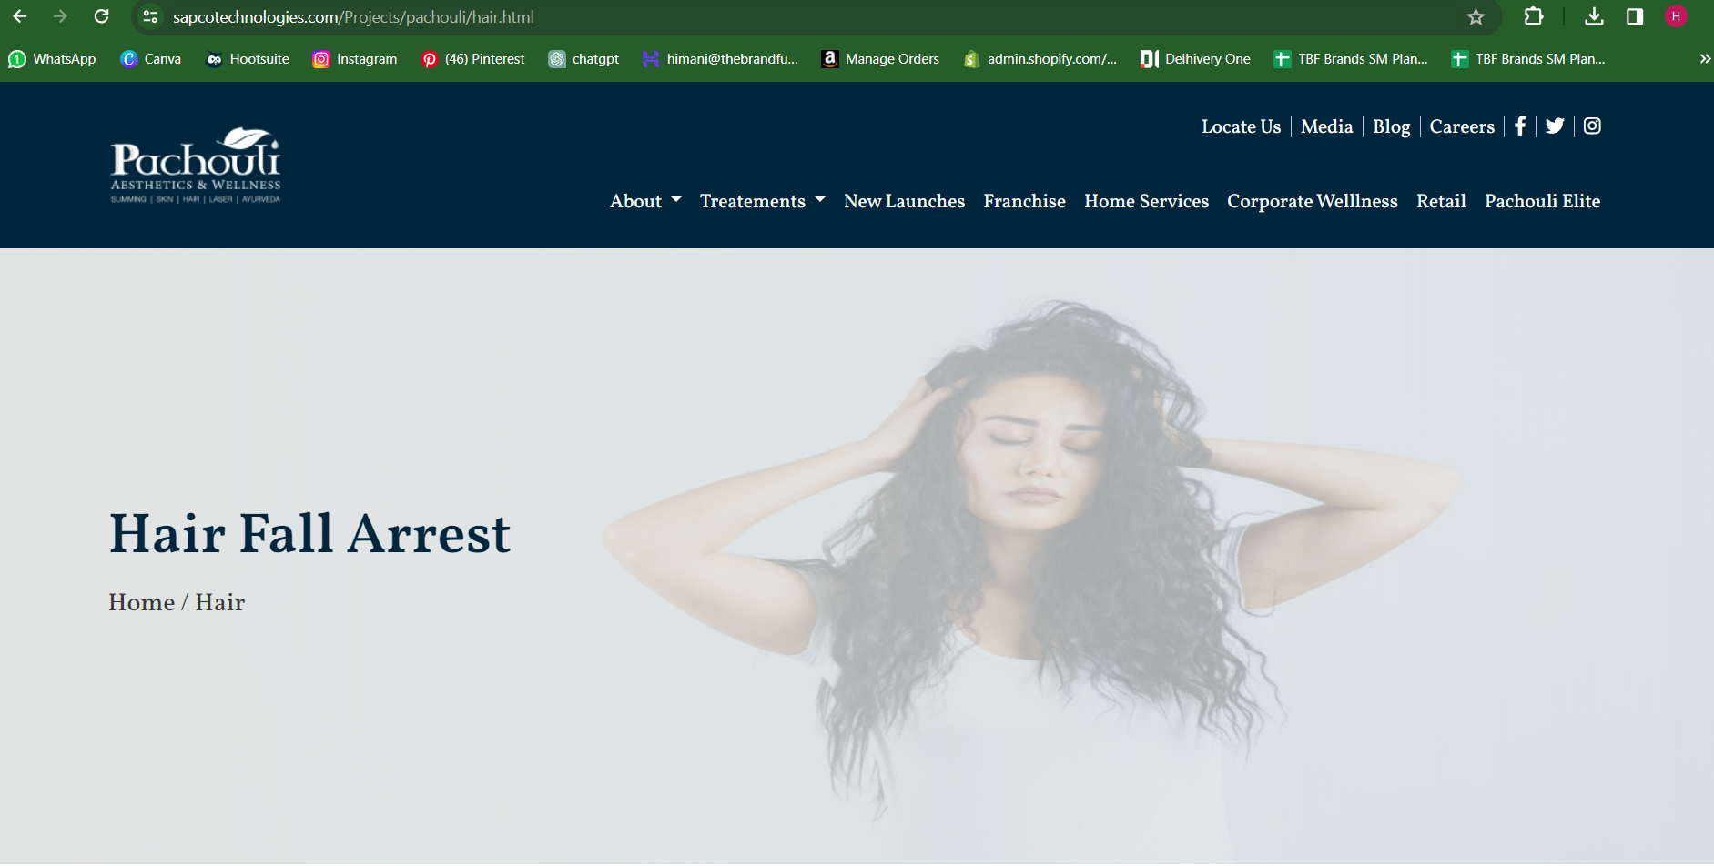

Change banner image and heading

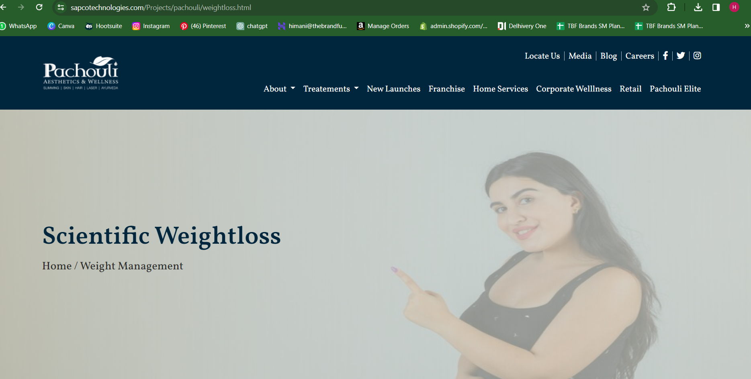

Change banner image and heading

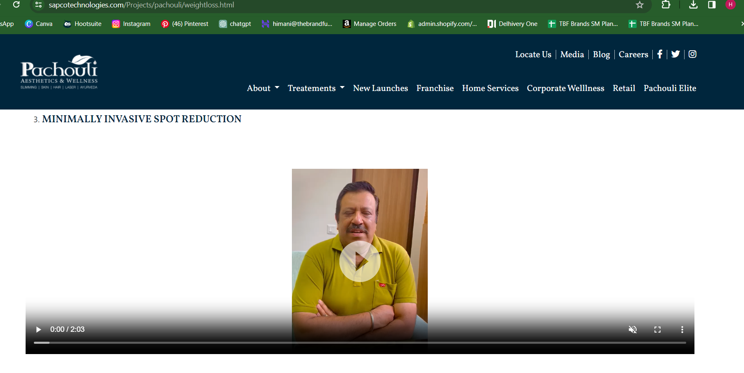

Home page testimonial video

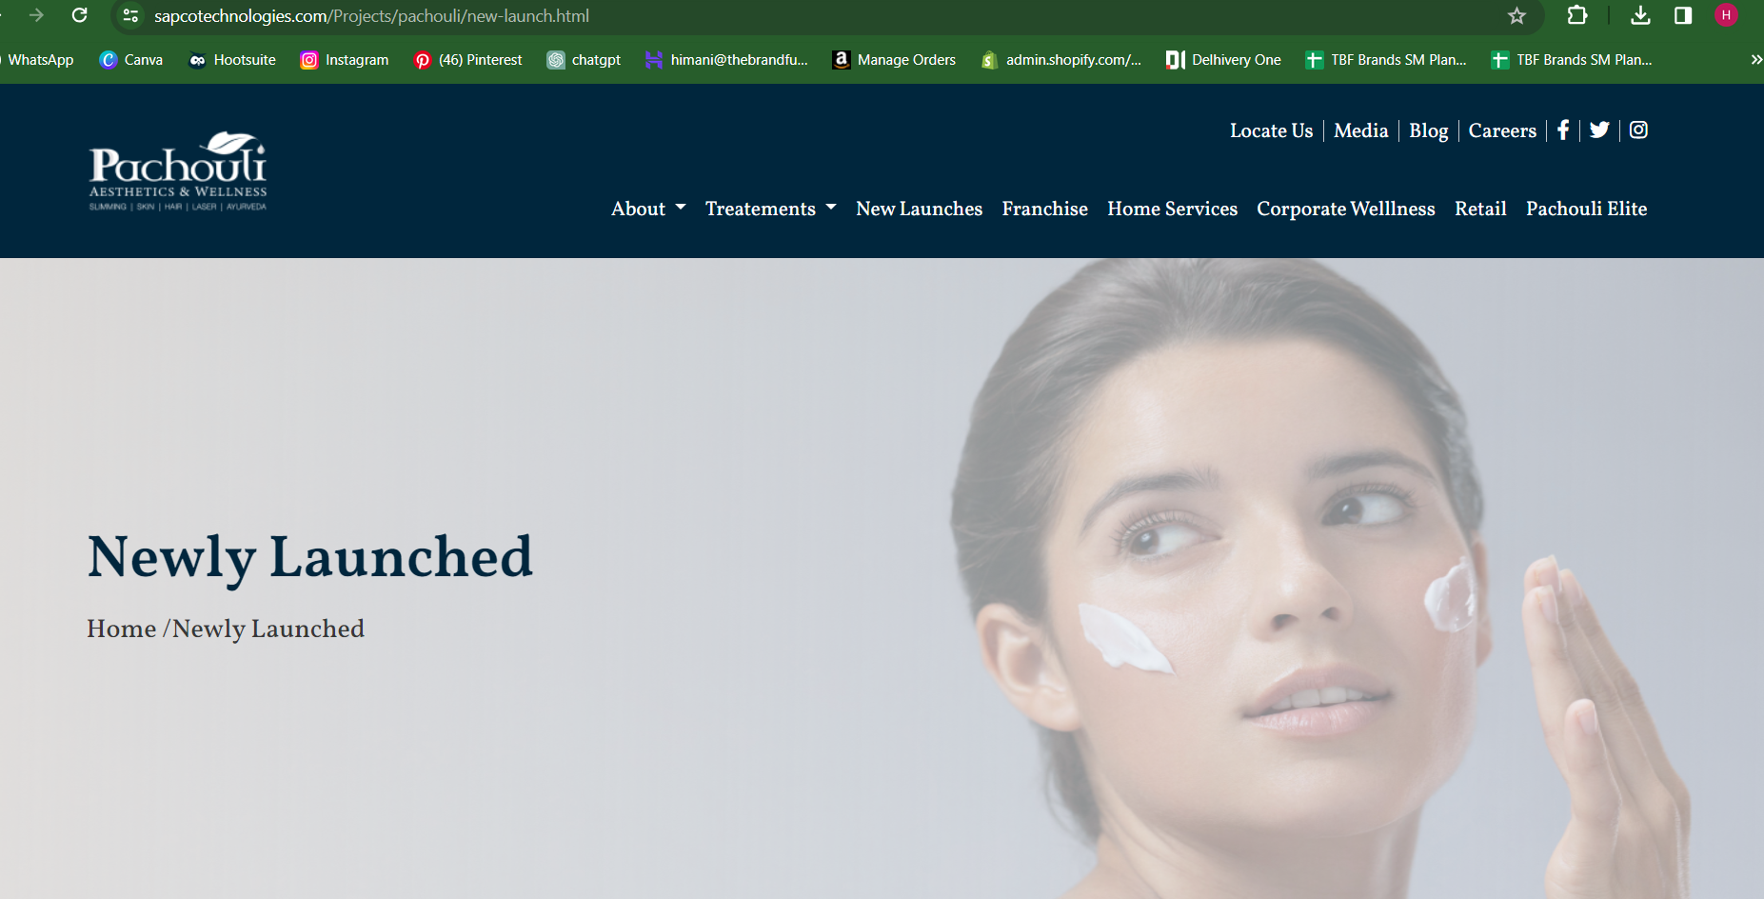

Change image- replace it with any of the new service based image

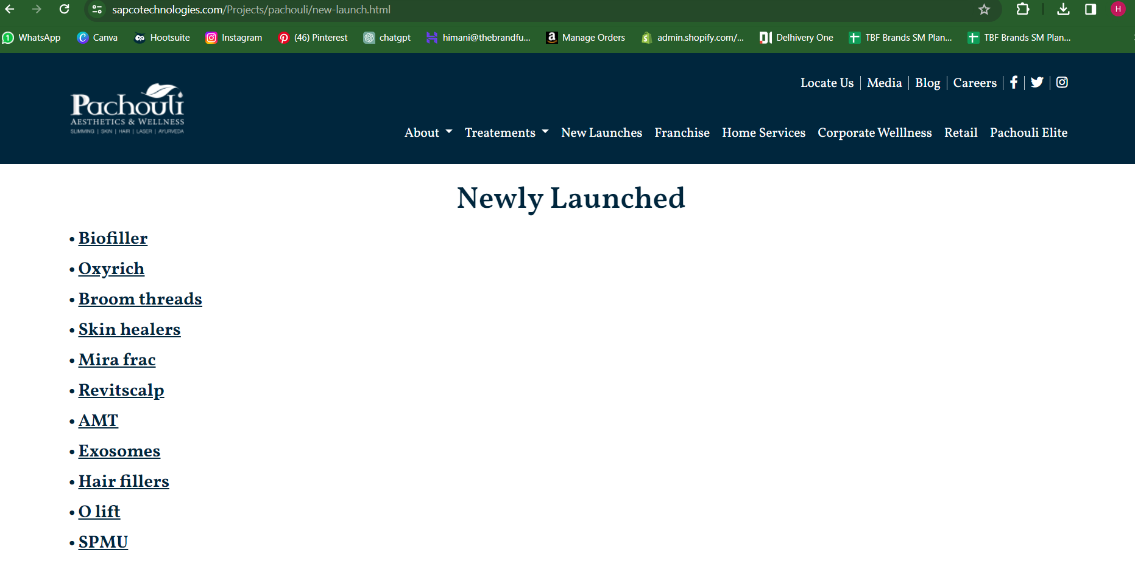

Pointers ki jgha small boxes bna do.. work on the overall representation of the website

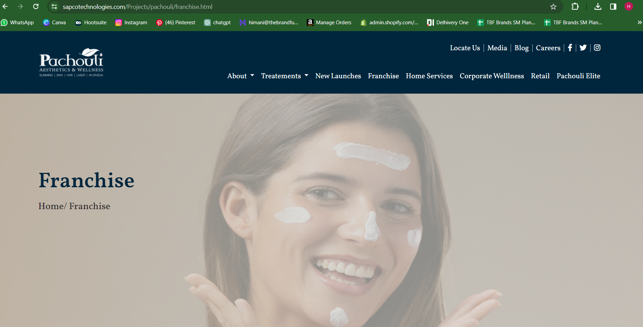

Kisi frenchise ki image aaegi..

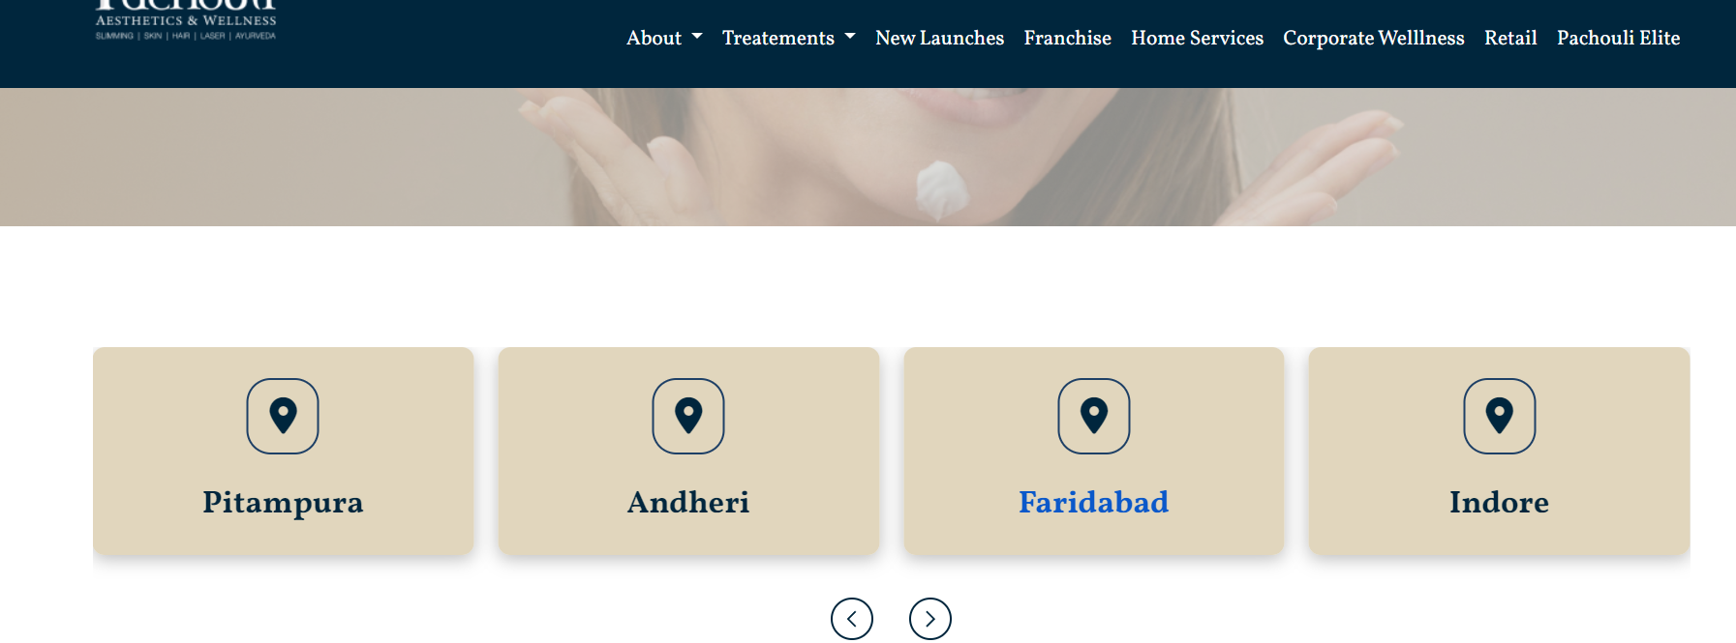  
use city illustration as icon. Eg- delhi me india gate

Phle major cities aaengi--- then uske andr ki local locations and when we click on each location, separate page should open

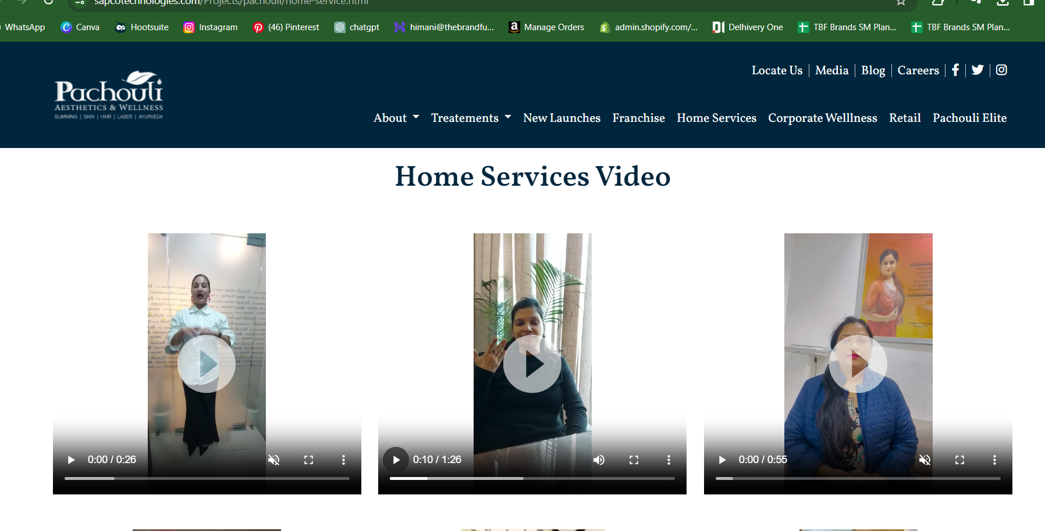  
home page testimonials

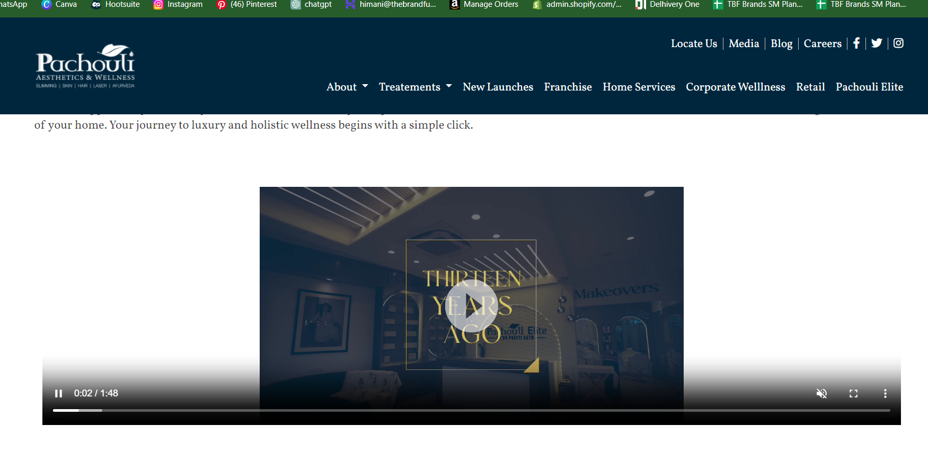

Ye video yaha aaegi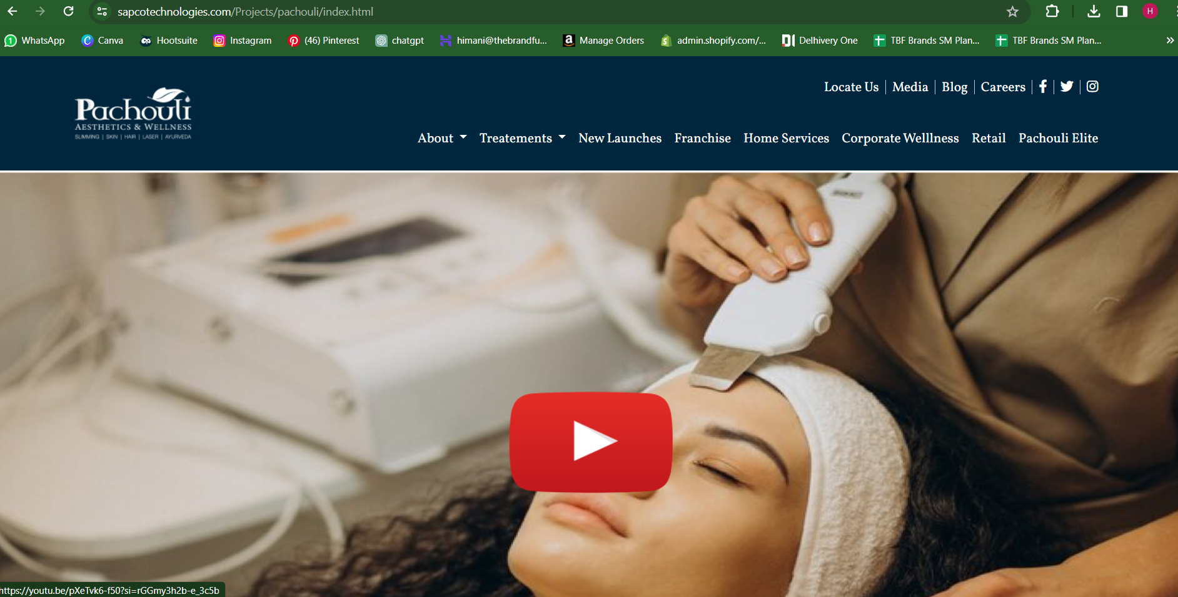

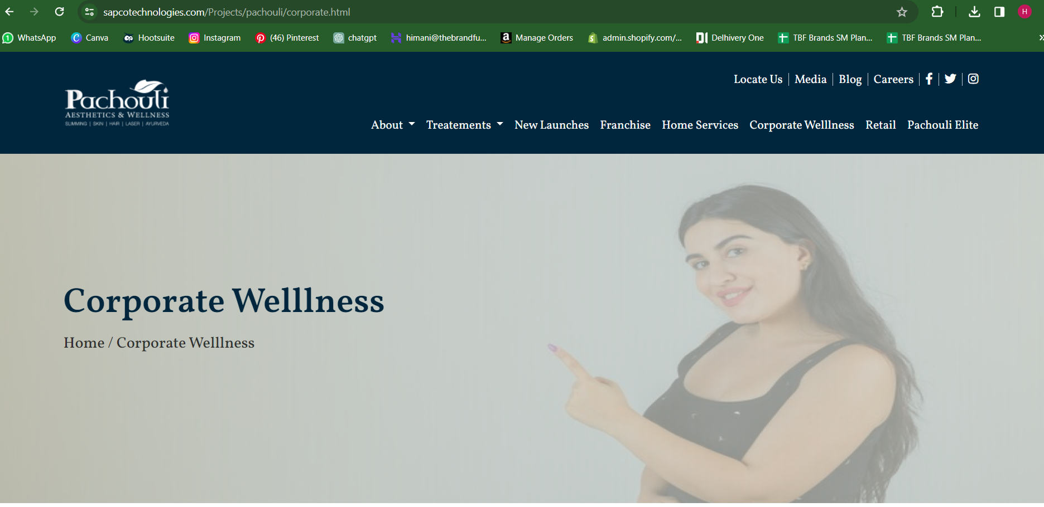

Change banner image

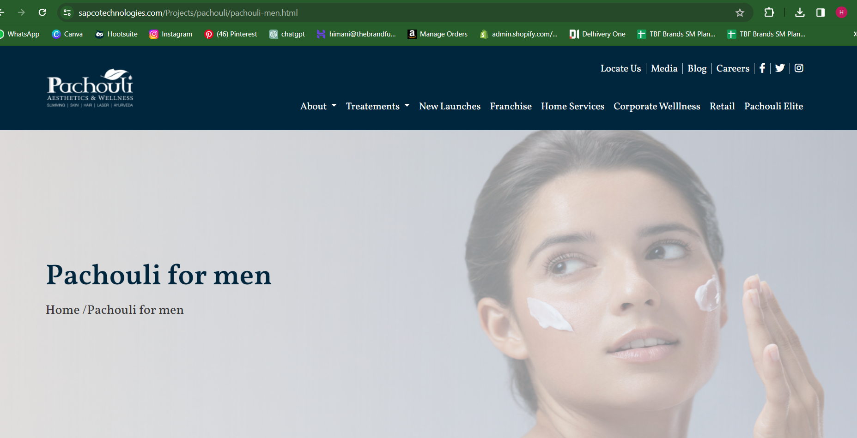

Create separate section for this on header.. don’t link it with pachouli elite  
for pachouli elite- https://www.pachoulielite.com/

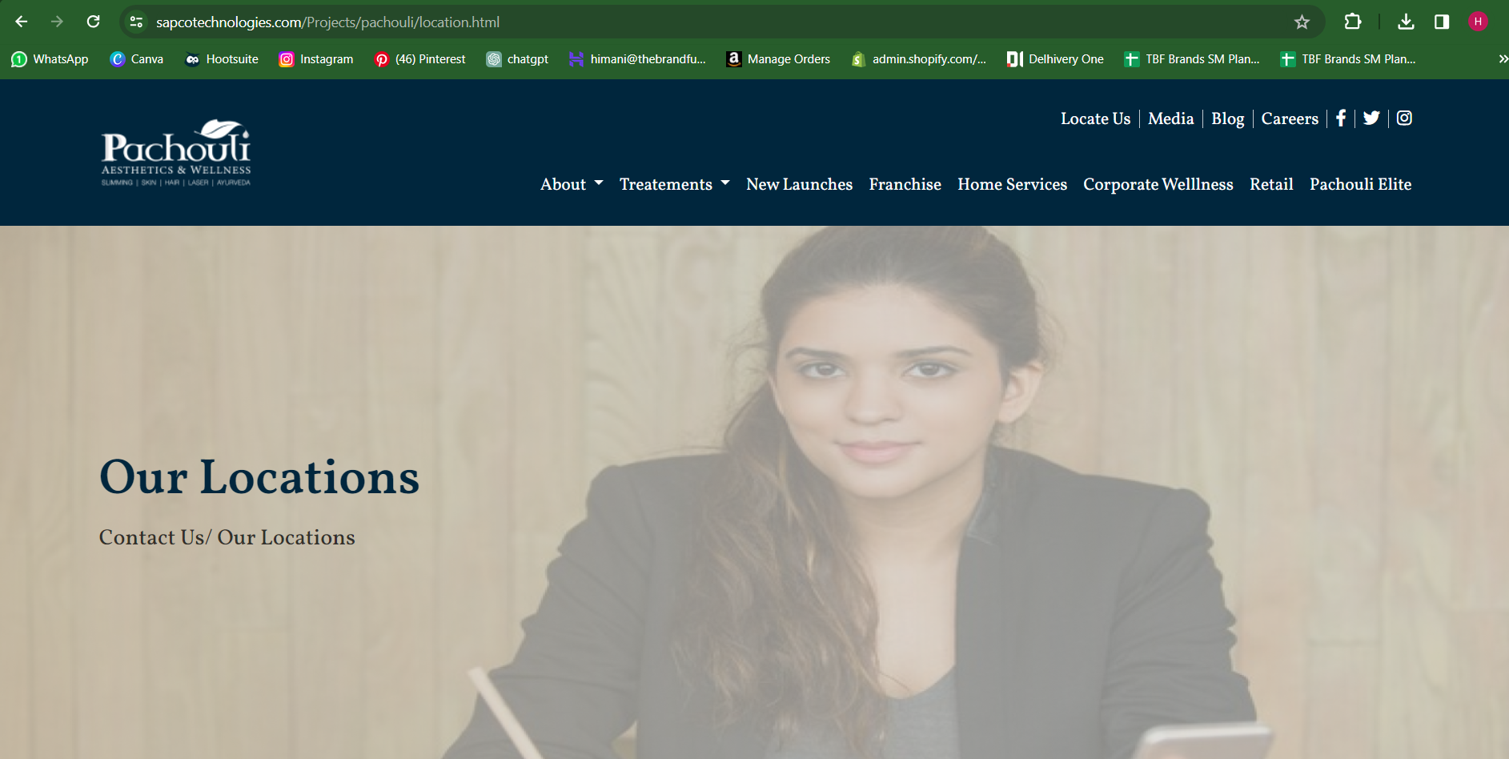

Update the locations and change banner

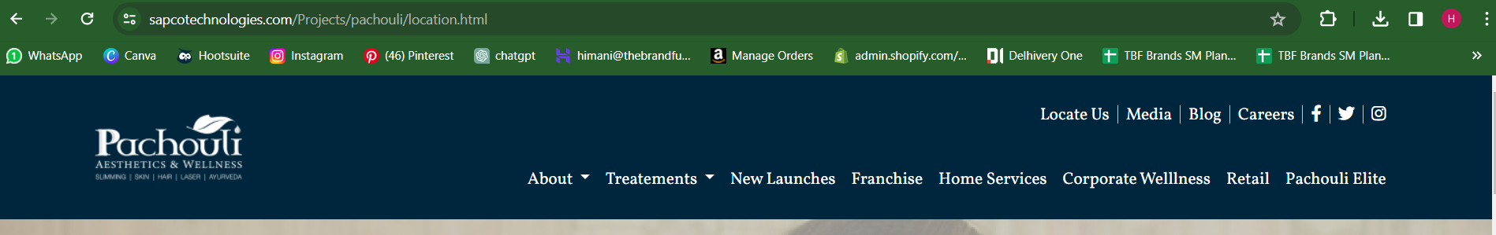

Media not working

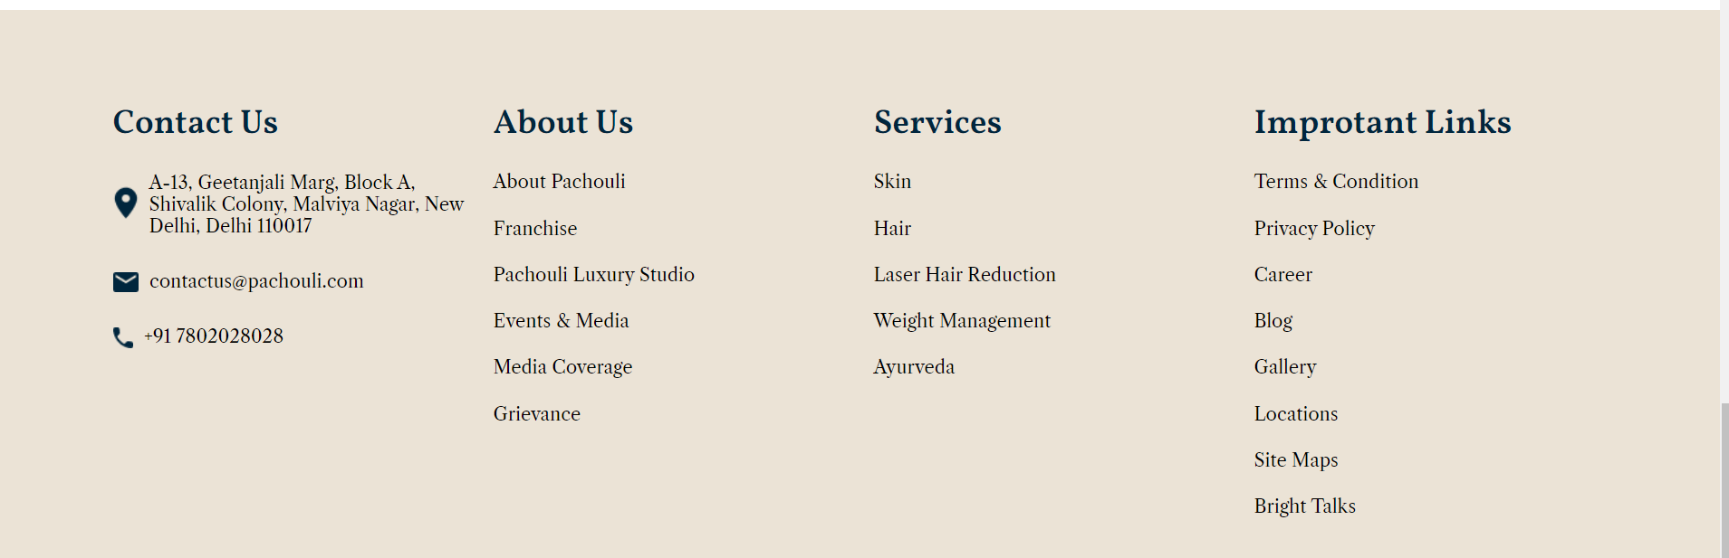

Check linking